Choose to Move is free and offered across the province. Based on research, it provides older adults with the motivation and support to become more active. Choose to Move can help participants integrate activity into their daily routine in a flexible way, meet new friends, and make a positive change. Participants receive both individual and group support to develop and stick to a personal activity plan that includes activities they enjoy and are able to do. Choose to Move is great for anyone age 65 and older that wants to become active. You can learn more at www.choosetomove.info.
Choose to Move is being delivered in [INSERT COMMUNITY NAME] at [INSERT FACILITY NAME] this [INSERT SEASON].
I encourage you to refer the seniors you serve to the upcoming Choose to Move program in your community. It is a great opportunity for them to get more active and become socially connected in an individualized, supported way.
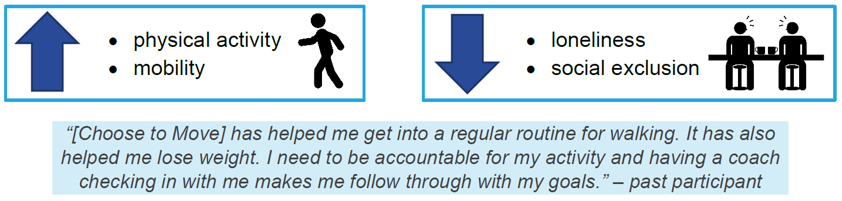
Early evaluation results from the Active Aging Research Team at UBC show that Choose to Move helps older adults to:

